**Star Conquest Battle system explanation**

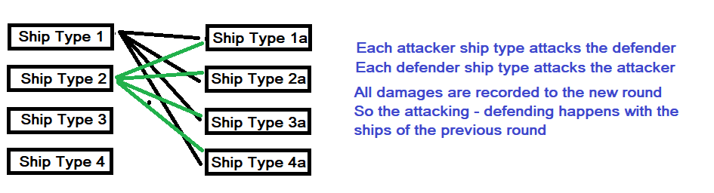

//Play the battle between 1 attack ship type and 1 defend ship type

//possible outcomes

//ATTACKER

//1) all ships fired (so this type will fire if survived the defender attack)

//2) some ships didn't fire (because the enemy was obliterated) so they should fire on the next ship type

//DEFENDER

//1) defender loses all ships

//2) defender sustains damage but lives

1. **function dotheshipbattle**

//an attack fleet of shiptype attacks all the defender fleets(shiptype by shiptype)

//in order to go to the next shiptype the current shiptype must be destroyed.

//for each fleet in defense

//get the ship types which survived

//for each enemy ship type in fleet

//if the attacker weapon distance can reach the ship type

// then

// get all defender shiptype info ();

// add (quantity,killed,damage,shipsnotfired(on previous attack))

// dotheshipbattle and as a result we have ships of this attack type that not fired

// do the same for the next defend ship type.

// and for the next defender fleet

1. **function attackenemyshipatrange**

//for each attacking shiptype in fleet

//get all attacker ship type info

//add quantity and coords

//and attack all enemy ships at range

1. **function doshipsattack**

//For each attacker fleet in battle

//attack all the defenders fleets

1. **dothebattle**

//Gets all attacker fleets in battle

//Gets all defender fleets in battle

//Copy all fleets to newround

//in new round

// dothebattle with attacker fleets attacking the defender fleets from previous round and record damages to this round

// dothebattle with defender fleets attacking back the attacker fleets from previous round and record damages to this round

//check if battle ended and set the time for next round

1. **donextround**

**Example1**

500 ST1 attack 300 ST1a

Attacker attack result

Defender loses 100 ST1a

Defender attack result

Attacker loses 75 ST1

On Next Round

Attacker will have 500-75 ST1

Defender will have 300-100 ST1a

Attacker attack result

Defender loses 80 ST1a

Defender attack result

Attacker loses 50 ST1

On Next Round

Attacker will have 500-75-50 ST1

Defender will have 300-100-80 ST1a

**Example2**

500 ST1 attack 20 ST1a

Attacker attack result

Defender loses 20 ST1a

Attacker fired with 200 ST1 to completely defeat defender ST1a

so that leaves 300 ST1 that can fire to another Ship type of defender

300 ST1 attack 200 ST2a

Attacker attack result

Defender loses 50 ST2a

Defender(ST1a) attack result

Attacker loses 5 ST1

On Next Round

Attacker will have 500-5 ST1 (minus whatever else the defender destroys during his attack)

Defender will have 0 ST1a

Defender will have 200-50 ST2a

**Battle Data & Calculations**

*Data for each battle between an attacker ship type and a different defender ship type*

**Attacker**

**$accuracy** calculated (distance between them, how far the weapon can fire, how fast the ship is in regard to the defender ship)

TODO: Add computers

$distpenalty=$accuracy*(($shipdist-1)/10); //because accuracy is maximum if the ships are near at distance 1

$weapondistbonus=$accuracy*(($weapdist-$shipdist)/10);//because weapon can fire longer than ship distance

$speeddiff=$accuracy*($speeddif/10); //because speed gives or takes an edge

return $accuracy-$distpenalty+$weapondistbonus+$speeddiff;

**$atkpower** the shiptypes attack power (All 3 weapons)

$atkpower += $atkweapdamg*($accuracy/10);

**Defender**

**$defpower** The shiptypes defense power (shields + hull armor)

$defpower =$defshldpower+$defarmor; //total damage defender

**Attacker total power**

$atktotalpower=$atkquant*$atkpower; Total attack ships * ship type attack power

**Defender total power**

$deftotalpower=$defquant*$defpower-$defprevdmg; Total defend ships * ship type defense power – previous damage inflicted

**Battle outcome**

$batresult=$deftotalpower-$atktotalpower; Simple subtraction Defender power – Attacker power

if ($batresult>0){ //defender lives but with damage (defender has more defesne power than attacker)

$defkilled=$defquant-($batresult/$defpower);

$damgremain=($defkilled-floor($defkilled))*$defpower;

$defkilled=floor($defkilled);

}

else { //defender obliterated

$defkilled=$defquant;

$damgremain=0;

}

How many of the attacker ships haven’t fired

//this is positive only if attacker has more power than defender

$shipsnotfired=-$batresult/$atkpower;

How many of the defender ships have remained to fight on the next round

//this is not zero when if defender has more power than the attacker

$defshipsremain=$defquant-$defkilled;

**Battle Visualization**

In each round we could have several fleets with several fleet types each of them.

Each ship type fight another ship type. Main variables on the battle are:

* Attacker shiptype*
* Attacker quantity of this shiptype*
* Attacker power of the ship type
* Attacker accuracy
* Attacker total power*
* Defender shiptype*
* Defender quantity of this shiptype *
* Defender defense power of this shiptype
* Defender total power *
* Attacker ships left to fire to another shiptype
* Defender ships killed *
* Defender ships left *

*🡨 possibly main variables

Those variables are valid for all user1 fleets and all user 2 fleets

Battle final report might include for each user and each ship type in battle

* Shiptype
* Total Quantity from all fleets
* Total Kills from all fleets
* Total Loses from all fleets